Purpose

This document covers the design overview and build steps for the Hornet.

Acknowledgements

The Hornet was built following early Beta Open Hornet designs. The Open Hornet project is nothing short of amazing, with full 3D cad models and electronic designs. Full credit to John (Noctum) and the team for delivering a truly open set of plans for the Hornet.

The bulk of communications occur on Discord.
https://discord.com/invite/G5PA5ju
https://openhornet.com/
https://github.com/jrsteensen/OpenHornet

The electronics used in this pit aren’t based on the Open Hornet stack as they Open Hornet stack wasn’t available at the beginning of the build.

Ben and Luke have been a big part of the team in building the Hornet in Oz. Thanks gents. Bens repository is full of useful bits and pieces (https://github.com/Ben-F111/Ben-F18-Sim-Pit), additional info is found on his Facebook page - https://www.facebook.com/BenF18Sim/

Table of Contents
Purpose 1
Acknowledgements 1
Systems Overview 3
Systems Design Approach 3
Hardware Design Approach 3
Switch and Analog Inputs 3
OLED, LED, Coil Outputs, Addressable RGB LEDs 4
DCS Systems Design Approach 4
Other Software Modules 4
Flight Panels DCS-BIOS Fork 4
Helios 5
Fly Elise 5
Component Details 6
Panel Backlighting 7
Power Supplies and Power Management 8
Rudder Pedals 8
Throttle Assembly 8
Right Console Utility Light 8
Computer Specifications 8
Computer Video Sub-system 9
2023 Computer Specification 9
The Curved Screen and Projectors 10
Building the Computer 11
Install Operating System 12
Assign Static IP Address to Ethernet Connecting to Pit 12
Install Development Environment 12
Install Backup/Imaging Software 13
Install DCS 13
Install MSFS 2020 13
Install Fly Elise 13
Install Orbx Central 13
Configure DCS 13
Install and Configure Flight Panels DCS-BIOS 13
Configure Keystroke Bindings for Magnetic Switches 14
Applying DCS Updates 14
Simulator Startup 15
Simulator Shutdown 15
To Do’s 15

Systems Overview

The Hornet currently supports DCS and MSFS 2020. DCS provides full system capabilities, whilst MSFS 2020 supports a basic aircraft tooling. The bulk of the interfacing with DCS uses the Flight Panels fork of DCS-BIOS. Further details on API usage and development can be found in Python HW Link - Design

The throttle and stick assembly are from WinWing (https://www.winwing.cn/en/JOYSTICK) and the rudder pedals are from MFG (https://mfg-sim.com/en/).

As the ADI is not natively rendered in DCS, Helios is used to generate the ADI. The Left and right DDIs along with the AMPCD can be easily exported, but views such the RWR/TEWS, do require a little more work to export.

Systems Design Approach

Where possible Off the Shelf building blocks and Open Source have been used to ensure longevity and adaptability of the pit. Code and Designs unique to the build (ie not Open Hornet components) are published in the Git Hub Repo (https://github.com/bnepethomas/bne-arduino-flight-simulator-interfaces). I’ll acknowledge now the filing system in the repo needs tidying up.

Hardware Design Approach

Whilst the ultimate goal is use as little USB connectivity as possible for simulator to pit communications, the bulk of the Arduinos are currently connected with USB and Ethernet.

Switch and Analog Inputs

The bulk of the Switch inputs are multiplexed to an Arduino Mega. The input Megas are located in the Left and Right Consoles as well as the UIP. A small PCB takes the ports 22 to 53 to an Expansion PCB that is specific to the area it is serving. This approach enables code to be easily shared and reduces the amount of bespoke troubleshooting. The current exception to this is the Standby Instrument inputs, which now have a dedicated Mega which deals with both inputs and outputs on the Standby Instrument Panel.

The of the panels has a panel specific PCB that connects all services required for that panel aside from backlighting, as the backlighting PCB has its own connectors. This panel holds the diodes used to prevent ghosting of the switch inputs.

The bulk of the analog inputs are connected to the input Megas using the same connectivity approach as switch inputs. A small capacitor is used to reduce the amount of electrical noise received on the Mega. One exception to this is the approach used to dim the AOA indicators. The AOA dimmer sends updates over Ethernet to the Mega responsible for driving the LEDs. The original PCB design used a small connector to bring the Mega Analog inputs up to the primary analog input PCB. Later releases extended the lower PCB to include the analog inputs with a header bringing the analog inputs to the riser.

OLED, LED, Coil Outputs, Addressable RGB LEDs

The UFC displays are OLEDs driven using an I2C Multiplexor. Originally the Adafruit libraries where used, but ultimately found the U2G library offered the greatest performance and flexibility.

Almost all of the LEDs in the pit are driven using Max7219s. As the Max7219 does not support individual LED dimming, LED outputs are grouped into regions, enabling individual dimming of the region. This means that some of the possible outputs are not used. All of the Max7219s are located on a single PCB and are daisy chained. LED outputs (which are matrixed), are then either connected to the assembly (such as the AoA) or connected to the output distribution PCBs in the left and right console.

Magnetic Coil outputs use UN2003 Darlington Drivers arrays. This are located on output distribution PCBs in the Left and Right consoles.

Addressable RGB LEDs (WS2812) are used for backlighting. There are design options for AoA, but the final build used LEDs driven by Max7219.

DCS Systems Design Approach

DCS and Magnetic Switches
Currently the DCS F18 module doesn’t provide the same level of support as the A10. If the DCS-BIOS interface is used to set a switch position, the simulator thinks the switch is being physically held in position. This prevents it being automatically released. Because of this, a different approach is needed to support the magnetic switches. Instead of using DCS-BIOS a message is sent from the input Mega over Ethernet to an Arduino Due. The Due in turn sends keystroke to the PC.

Other Software Modules

Flight Panels DCS-BIOS Fork
As the original author [FSF]Ian of DCS-BIOS is no longer maintaining DCS-BIOS, another team is maintaining a fork of it. Two of the DCS Flightpanels repositories are used in this project. One is the Arduino library, and the other is the PC side which sends the data streams to the Arduinos over USB. Whilst there is mention of Ethernet, specially multicast, it does not appear be heavily used.
https://github.com/DCSFlightpanels/dcs-bios
https://github.com/DCSFlightpanels/dcs-bios-arduino-library
Unlike the original DCS-BIOS, Flightpanels DCS-BIOS does support resuming a flight after edits, which seriously speeds up coding and troubleshooting as flights no longer need to be exited and restarted.
The PC monitoring gui is currently a plug-in for the Chrome browser, once you’ve worked out how to install and activate it, the plug-in is a very useful monitoring tool.
SOCAT is used to send data to Arduinos, a 32 and 64 bit is included, requiring you to copy the desired version to the folder above.
It is possible to create a shortcut of the CMD to the task bar, but it does require a bit of goofing around, you can’t simply drag a shortcut of the CMD file to the taskbar.

Helios
Helios, among other things, renders instrument and updates values using a LUA feed. Helios is now only needed for the ADI as the other steam instruments are no longer using a screen.

Fly Elise
Fly Elise provides both design and operate capabilities for curved screens. The curved screen was designed using Immersive Designer PRO. Design Pro is able to generate monitor configuration files used by DCS, and hopefully MSFS 2020 in the future.
I’m still yet to get to the bottom of why I see image drift when using the projectors. It could be due to the following:
- Slight movement in the ceiling
- Temperature changes in the projector itself
- The projector reverting to automatic keystone correction. Generally for the simulator it is recommended that automatic keystone correction is disabled.
Explicitly setting hot-keys should be done for Fly Elise, as the default mappings may conflict with the default settings in the setting in DCS or MSFS 2020.
Currently the multi-view capabilities in MSFS aren’t geometrically accurate, so support is currently not provided in Fly Elise (as of October 2020).
When running DCS you will get a very unusual experience when you enter the flight. Its important not to enable simulator specific capabilities until the flight has started. Once the flight is loaded the screen will look very distorted, but once the simulator capabilities are enabled the view will come good.
Blog Updates regarding MSFS 2020
https://fly.elise-ng.net/blog/microsoft-fligh-simulator/ - August 22, 2020
Our latest Immersive Display PRO v4.3.0 supports warping and blending of Microsoft Flight Simulator 2020, both for Standalone Edition and for Steam Edition.
However, there is a catch. Although this initial version of MSFS supports multiple outputs and multiple monitors, it does NOT support multiple windows (at first). So you will be able to use several monitors for a single view but you won’t be able to open multiple views or use a 2nd window for instruments.
This is a huge limitation for being able to use MSFS for true geometrical outside views in a multi-projection or multi-LCD systems. Only a single view (spanned displays) can be used with the limitation of the maximal FOV that can be achieved with a single view, which is about 100 degrees. Larger FOVs will cause the so-called pinch distortion.
In order to get 100% accurate and geometrically correct images, our Immersive Calibration PRO calculates the needed view parameters (FOV and orientation) to produce perfect and undistorted views with no FOV limitation. But , in order to be able to use those views, MSFS must support the so-called multi-view or multi-window functionality.
Unfortunately, at this moment, MSFS does NOT support this, and multi-view setups are not possible.

https://fly.elise-ng.net/blog/multi-view-perspective-correction/ - July 16, 2021
Designing the projection setup for 100% accurate and true geometric correction for 3D game engines and simulation setups requires even more attention and design considerations. Computer generated graphics and perspective views have a limitation of the total field of view (FOV) that can be rendered to a single view. In practice, rendering FOVs of 100 or more degrees will result in a “pinch” distortion and unusable view. As a consequence, creating a visual projection setups with FOVs of 180 or larger horizontal FOV, requires a 3D game engine to generate multiple views. Each view will be generated with a FOV of less than 100 degrees and combined and edge by Immersive Display PRO.
Almost all flight simulators P3D, DCS, X-Plane as well as all graphics engines like Unity, Unreal, etc.. already support configurable multi-view rendering.
However, combining multiple perspective views as one continuous undistorted image on a curved projection screen requires additional image geometric correction (stretching and squeezing) which is dependent on the physical projection setup, projection screen, projectors light path and the designed eye-point.
Designing a projection setup for multi-view projection involves additional analysis for projector pixel utilization and image stretching from a design eyepoint.
The latest version of Immersive Designer PRO introduces a new analysis module for analysis and evaluation of the perspective image pixel utilization and stretching.

Component Details

Panel Backlighting

The Panels are driven by a hardware solution developed by Luke. It uses PCBs with SMD (Surface Mounted) LEDs, which enable knobs to be effectively backlit, something that is difficult when using through hole LEDs.
The LEDs used are from the WS2812B family, who do not have a separate clocking or data load pin. This has the major benefit of enabling 100’s of LEDs to be driven with a four wire interface (Power, Ground, Data-In, Data-Out). It does however introduce a timing consideration, the LEDs expect a constant data feed when updating, i.e. the Arduino library (FastLED) should not be interrupted when doing an update. If it is interrupted all sorts of strange colours and state is encountered, often toward the end of the led chain. As the Arduino DCS-BIOS library uses interrupts to receive serial data over the USB interface, and most Arduino CPUs are only single threaded the DCS-BIOS and FastLED are not good neighbours with long LED chains.
This challenge was solved by splitting DCS-BIOS and the FastLED library onto two Arduino’s with the DCS-BIOS Arduino sending lighting updates over Ethernet to the FastLED library.
Some devices are backlight using PWM, this includes some of the first generation of gauges. Later gauges (eg Standby Instruments) use the 5mm Through hole WS2812 LEDs.
The backlighting levels are derived from DCS-BIOS, the Flight Panels fork presents these values, whereas the original DCS-BIOS does not.
A design note when using ground and power planes with PCBs, Thermal Reliefs should be included as this reduces the amount of heat needed to solder or remove a device. For reference - https://resources.pcb.cadence.com/blog/2021-pcb-thermal-relief-guidelines-for-effective-layouts.
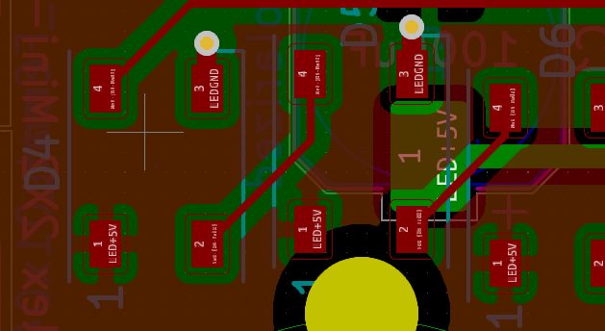
The 5mm NeoPixel LEDs used in the Standby instruments use a different colour encoding, From (https://www.adafruit.com/product/1938), ‘These are "RGB" instead of "GRB" format used in the 5050-sized LEDs you are so used to’.

Power Supplies and Power Management

A single PC power supply powers all devices in the pit. This includes the USB Hubs, Backlighting, and Monitors.
Some of the power rails are controlled by relays to give a full dark pit experience. Whilst there was concern about the monitors loosing their position on the PC – it appears to hold
The current orientation of the power supply is not ideal, with the fans bearings making a noise on initial power up. Ultimately it should be relocated or reorientated.

Rudder Pedals
The pedals are MFG Crosswinds, and are beautifully engineered. The optional Damper is well worth the investment. The footrests aren’t from MFG, at the time of purchase, a team on the DCS forums was manufacturing F-16 footrests (https://forum.dcs.world/topic/256148-mfg-crosswind-f-16-combat-pedals/)

The pedals are mounted on a plate driven by a motor, enabling the pedals to be adjusted using a switch in the forward lower panel assembly. Limit switches are used. The plate is mounted on a pair of rails.

Throttle Assembly
As the WinWing throttle was not part of the original Open Hornet design the panels to the left and forward of the throttle required modification.
The throttle was removed from its outer enclosure, and the backlighting was modified, in that is not longer driven by the WinWing electronics, but instead is driven by the custom PWM (Pulse Width Modulation) dimmer. Additional resistors were added to allow the LEDs to be driven by 12V.

Right Console Utility Light
The light is a genuine Utility Light with a 24V bulb. It is driven by an inverter which has its power supply controlled by a near-by switch.

Computer Specifications

The following capabilities are desired
- Dual Wired Ethernet Interfaces, one for the Arduinos, the other for high performance connectivity such as last software updates and over the wire backups.
- WiFi interface for general connectivity
- Sound card with front and rear ports
- Six USB Ports
- Removable SSDs to facilitate high performance backups and swapping of simulator personalities (eg swap between DCS A10 and F16)
- Three high performance HDMI interfaces for the primary screens
- Ideally an HDMI port for the operators screens
- Four HDMI ports for the DDIs, AMPCD, and the standby ADI and RWR.
- An additional three video ports for the mirrors.

Computer Video Sub-system

With a minimum eight video ports there are some challenges in meeting these requirements. If mirrors are desired, a total of 11 ports are needed.
The original PC had a Nvidia 2080TI and a smaller three port Nvidia.
Ben found a four Port USB-3 video card which provides solid performance for DDIs and AMPCDs. The Startech USB32HD4 USB 3.0 to 4 HDMI Adapter - Quad Monitor lands around AU$270.

2023 Computer Specification
The PC was originally running a Nvidia 2080, it is intended to refresh the PC with a higher specification video card as a number of Blue Screens had occurred leading to the original PC not being able to boot.
The replacement PC is this configuration.
- Intel S1700 Core i9 13900K 24 Core CPU BX8071513900K
- Corsair iCUE H150i RGB ELITE Liquid CPU Cooler CW-9060060-WW
- MSI S1700 E-ATX MEG Z790 ACE DDR5 Motherboard
- 64GB DDR5 (2x32G) Corsair 5200MHz CMT64GX5M2B5200C40 Dominator Platinum RGB RAM
- Samsung 990 PRO PCIe 4.0 NVMe M.2 SSD 2TB - MZ-V9P2T0BW
- Nvidia Quadro T600 4GB PCIe Video Card 900-5G172-2520-000
- Gigabyte RX7900XTX 24GB PCIe Video Card GV-R79XTX-24GC-B
- Corsair Full ATX Obsidian 1000D Tempered Glass Case Black (No PSU) PN CC- 9011148-WW
- 120mm Noctua NF-A12x25 FLX 2000RPM Fan
- 1200 Watt Thermaltake Toughpower GF3 Gen5 Power Supply PS-TPD-1200FNFAGA-4
- Microsoft Windows 11 Home 64bit DVD KW9-00632

The Curved Screen and Projectors

The curved screen was supplied by Mocomtech (https://mocomscreens.com). It has a radius of 1500m and a height of 1600mm. Once the design was complete using fly Elise Design Pro, the process of ordering and shipping was very smooth.

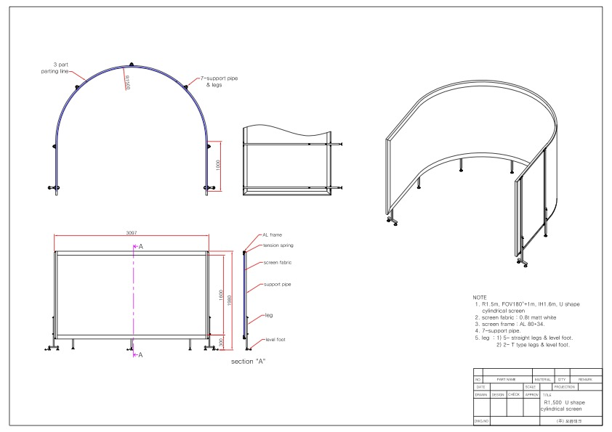
Three BENQ Short Throw 4K Projectors are used. With the high datarate associated with the 4K screens I found the older 10m HDMI leads no longer provided a reliable connection. I also have challenges with the Displayport to HDMI Adaptors.

Building the Computer

Building the Computer
Building the Computer 10
Install Operating System 11
Assign Static IP Address to Ethernet Connecting to Pit 11
Install Development Environment 11
Install Backup/Imaging Software 11
Install DCS 12
Install MSFS 2020 12
Install Fly Elise 12
Install Orbx Central 12
Configure DCS 12
Install and Configure Flight Panels DCS-BIOS 12
Configure Keystroke Bindings for Magnetic Switches 13

Install Operating System

Assign Static IP Address to Ethernet Connecting to Pit

A static address (172.16.1.10/24) is used to receive switch events for MSFS 20202 as well as monitoring updates from the Arduino environment. If this address is not defined DCS interfaces will operate but updates may be slow due to the Arduino waiting for a timeout in resolving the ARP for the reflector. If it is not planned to use this link then is it recommended the following values be set to 0 in the Arduino code.
#define Reflector_In_Use 1
#define MSFS_In_Use 1

Install Development Environment
- Install Github – add primary repository
- Install Arduino IDE – including libraries used (built-in if author is not listed)
  - FastLed 3.3.3 – Daniel Garcia
  - Ethernet – 2
  - Keyboard – 1.0.3
  - Mouse – 1.0.1
  - Servo 1.1.6 – Michael Margolis
  - Stepper 1.1.3
  - AccelStepper – 1.61.0 – Mike McCauley
  - Adafruit GFX Library – 1.2.2
  - Adafruit SSD1306 – 2.3.0
  - LedControl – 1.0.6 – Eberhard Fahle
  - Nextion – 2.0.2 – Helder Rodrigues
  - U8g2 – 2.27.6 – oliver
  - U8g2_for_Adafruit_GFX – 1.7.0 – oliver
- Install Python – minimum release 3.10 (for Case Statement support)
  - Install python modules

Install Backup/Imaging Software
- (currently use Acronis True Image – but the perpetual licenses are no longer available – so may need to look for alternatives.

Install DCS

Install MSFS 2020

Install Fly Elise
- Play the USB dongle in a port
- Install Fly Elise
- Start Fly Elise and Validate correct details are displayed in the license screen
- Refer to “Building and Deploying A Curved Screen” for further details. Of note is the importance of allocating keystrokes to:
  - Start Warp
  - Stop Warp
  - Enable 2D Warping
  - Enable 3D Warping
- Start MSFS 2020 and validate screen is correctly displayed. MSFS SU 10 enabled Surround and multiscreen support which improves the curved screen experience. Largely it reduces the distortion encountered ad the edges of the screen, ideally meaning lampposts are no longer leaning over. The Fly Elise team have noted that the surround view support still has room for improvement (as of Oct 2022).

Install Orbx Central
- Note different pits may operate under different accounts
- Download scenery of interest

Configure DCS
- Start DCS and load desired modules (eg Syria, Hornet)

Install and Configure Flight Panels DCS-BIOS
- Connect the pits USB port
- Statically assign COM Port numbers for the Arduino’s using the noting the Arduino Serial Numbers
- Ben’s document provides a useful guide to setting up Flight Panels DCS-BIOS fork (DCS-BIOS-FLIGHTPANELS.pdf)
  - THE FOLLOWING STEPS NEED TO BE VALIDATED!
  - Copy the SOCAT.EXE to the correct directory
  - Edit the batch file to reflect the serial ports in use.

Configure Keystroke Bindings for Magnetic Switches
Configure Monitors
- Now the Pit is installed we can complete configuration for the monitors and screens.
- Determine Monitor Layout. Optionally save the monitor layout using
- Configure Monitor related LUA files. Unfortunately DCS doesn’t provide a simple way to configure multiple monitors.
- Configure RWR – can add rings https://forum.dcs.world/topic/241306-fun-with-rwr-exporting-and-a-question-on-scaling-a-texture-through-lua/

Applying DCS Updates

It is common for DCS to update the LUA files associated with the TEW and one other of the outputs. A reasonable approach is to keeping a renamed copy of the master in the same directory and then copying it over the updated files.

Simulator Startup
- Power on the Projectors – wait for them to display an image
- Power on the Simulator using the Power Switch located next to the throttle.
- Monitor startup actions of gauges and back panel lighting
- Power on the PC
- Start SOCAT and validate all COM ports move to a good position.
- Start Fly Elise (only 2d)
- Start DCS
- Start Flight
- Change Fly Elise to 3d mode

Simulator Shutdown
- Exit the Simulator
- Shutdown SOCAT
- Shutdown Fly Elise
- Shutdown and fully power off the PC. This ensures nothing is receiving USB power via the PC
- Shutdown the projectors
- Power down the pit.

To Do’s
- I’m still yet to work out how you determine which build of DCS Flightpanels you are running on the PC. This is needed to determine if you are up to date as the library does receive active development.
- Determine source of image drift on screens. Lock room temperature to 23 degrees for 30 minutes and monitor.

Useful URLS

